Summerville Federal Credit Union
nFinia Digital Banking Platform

Loan Repayment
Feature Release Notes & Product Guide

Prepared by: Jeeva Krishnamurthy, Senior Product Manager
Tyfone, Inc. | April 2026 | Confidential

1. Product Summary

Loan Repayment is a core feature of the nFinia Digital Banking platform that enables credit union members to make payments on their loan accounts directly through the digital banking portal. This capability covers one-time payments, scheduled recurring payments, and multiple payment option types including regular payments, next-due-amount payments, payoff amounts, and pay-to-principal options — all accessible through the Transfer Funds to Own Account workflow.

Within the Summerville Federal Credit Union digital banking portal, Loan Repayment is accessible from the Account Details page of any loan account via the “Make Payment” link, or through Move Money > Transfer Funds to Own Account by selecting a loan account as the destination. The feature integrates with the platform’s existing fund transfer infrastructure, providing a guided three-step workflow (Set up Transfer → Review → Finish) that ensures members can make informed payment decisions with clear confirmation at each stage.

For Summerville FCU, Loan Repayment reduces delinquency rates by making it effortless for members to stay current on their obligations. The self-service capability deflects routine payment inquiries from the contact center, while the recurring payment option promotes consistent repayment behavior. Members benefit from 24/7 payment access, flexible scheduling, and the ability to make additional principal payments to accelerate their payoff timeline.
At a Glance
Attribute | Detail
Feature Name | Loan Repayment (Transfer Funds to Own Account — Loan)
Module | Move Money > Transfer Funds to Own Account / Accounts > Account Details > Make Payment
User Roles | Primary Account Holder, Joint Account Holder, Delegated User (with Transfer permissions)
Access Level | Account-level; requires active loan account and funded source account
Key Actions | Make Payment, Schedule Recurring Payment, Pay Next Due Amount, Payoff Loan, Pay to Principal
Supported Core | Ultra Data (UD); standard nFinia transfer infrastructure
Regulatory Relevance | Payment confirmation, transaction audit trail, scheduled transfer disclosures

2. Use Cases

Use Case | Who Uses It | What They Do | Business Value
Make a one-time loan payment | Account Holder | Navigates to loan Account Details, clicks Make Payment, selects source account, chooses payment amount, enters transfer date, reviews and confirms | Enables self-service loan payments without branch visit; reduces delinquency risk
Set up recurring loan payments | Account Holder | During transfer setup, checks “Make transfer recurring,” selects frequency (weekly, bi-weekly, monthly), sets end date or repeat count, reviews and confirms | Automates payment schedule; promotes consistent repayment behavior and reduces missed payments
Pay next due amount | Account Holder | Selects “Next due amt” from payment option dropdown to automatically populate the minimum payment due | Simplifies minimum payment process; ensures member pays exactly what is owed for the billing cycle
Make a payoff payment | Account Holder | Selects “Payoff amount” from payment option dropdown to populate the full remaining balance | Enables loan payoff without calling for a payoff quote; accelerates loan closure
Pay to principal | Account Holder | Selects “Pay to principal” to apply the entire payment directly to the loan principal | Allows members to reduce principal faster, lowering total interest paid over the loan term
View loan account and payment history | Account Holder | Views Account Details showing amount due, payment due date, overdue status, payoff amount, and full transaction history | Provides complete loan visibility; helps members track payment progress and remaining balance

These use cases reflect the primary loan repayment scenarios for Summerville FCU members. The combination of flexible payment options, recurring scheduling, and self-service payoff capabilities addresses both the credit union’s goal of reducing delinquency and the member’s need for convenient, transparent loan management.

3. End-to-End Workflow

3.1 Prerequisites
• Member must be enrolled in Summerville FCU digital banking with an active membership.
• The member must hold at least one active loan account (auto loan, personal loan, mortgage, etc.).
• The member must have a funded source account (checking or savings) from which to make the payment.
• Transfer permissions must be enabled for the member’s role (relevant for delegated access users).
3.2 Step-by-Step Workflow
Step 1: View Loan Account Overview
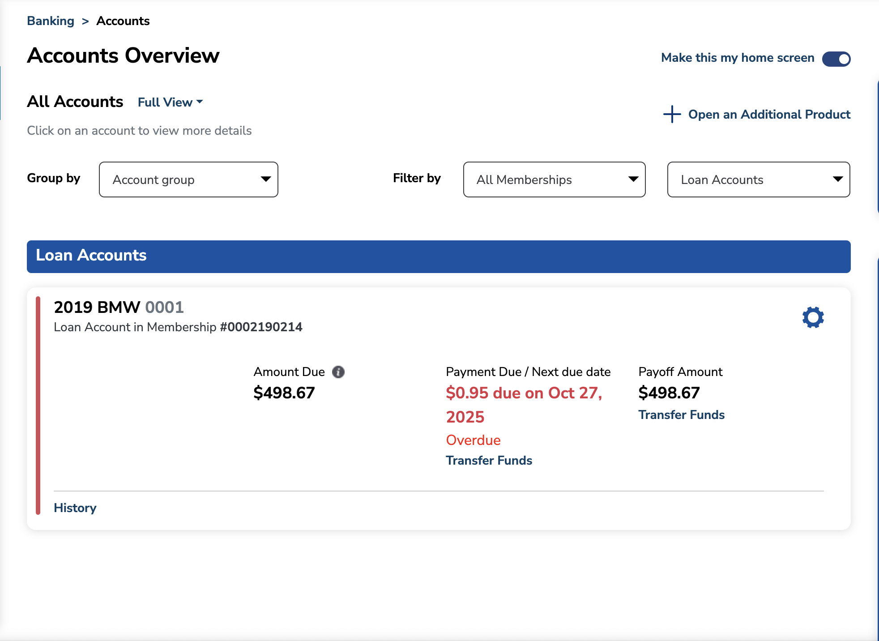
The member logs into the Summerville FCU digital banking portal and navigates to Accounts Overview, filtering by Loan Accounts. The overview displays each loan with its account name (e.g., “2019 BMW 0001”), Amount Due, Payment Due / Next Due Date, Payoff Amount, and quick action links including “History” and “Transfer Funds.” Overdue loans are highlighted with a red “Overdue” indicator and the next due date in red text.
Step 2: View Loan Account Details
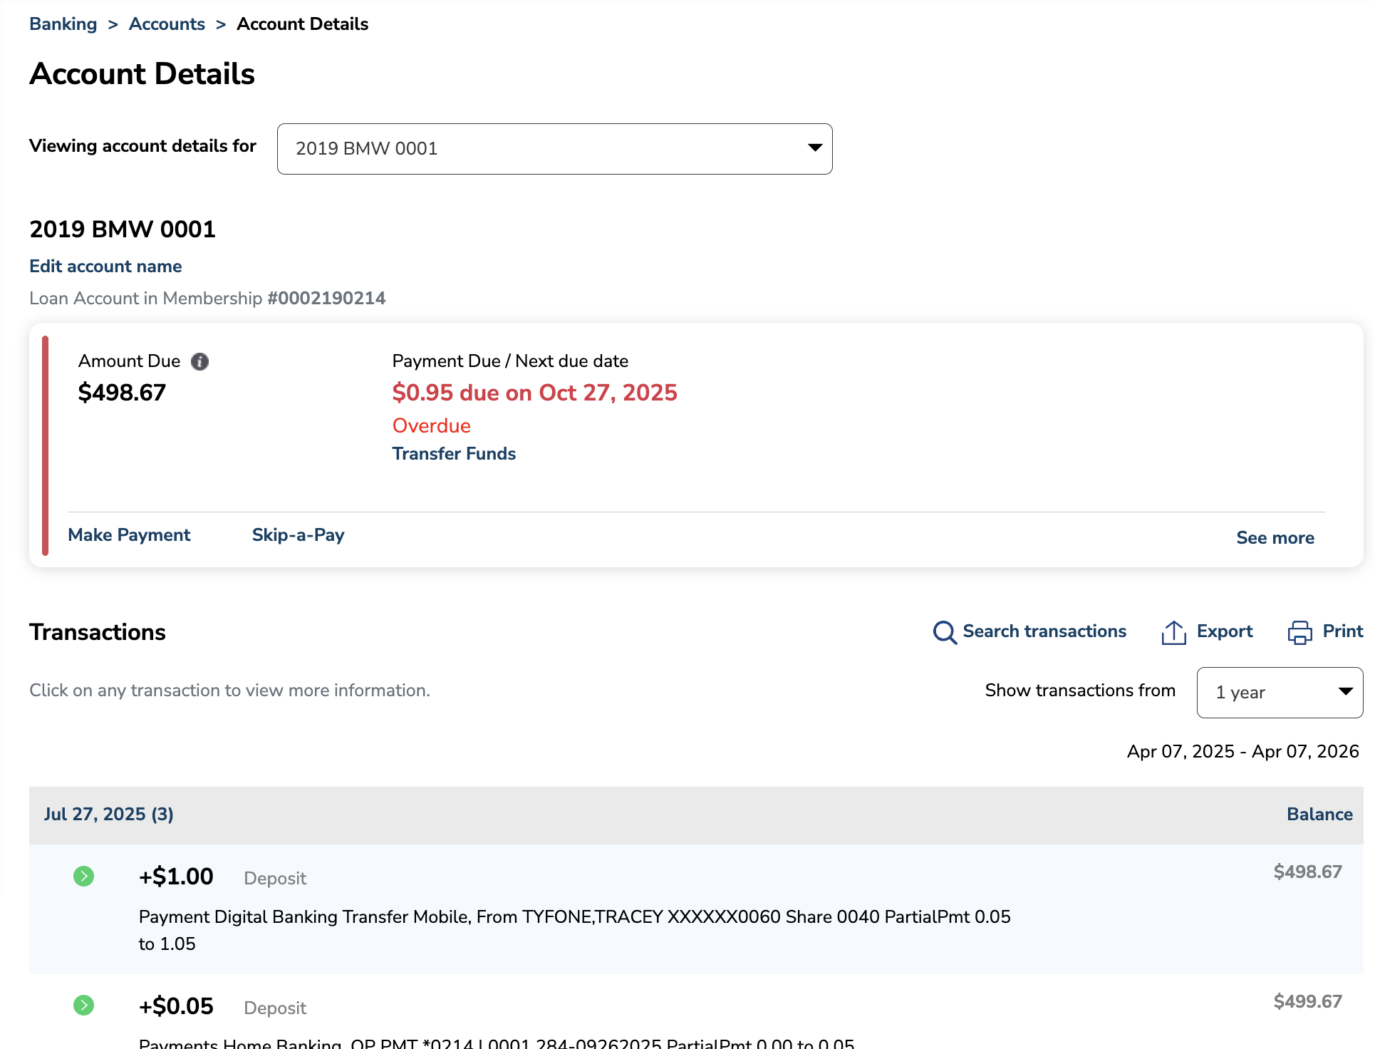
Clicking on the loan account opens the Account Details page, which provides a comprehensive view of the loan including Amount Due ($498.67), Payment Due / Next Due Date ($0.95 due on Oct 27, 2025), and links to “Make Payment,” “Skip-a-Pay,” and “See more.” Below the summary card, the Transactions section displays the full payment history with deposits, payment credits, and balance progression. The member clicks “Make Payment” to initiate the loan repayment workflow.

Step 3: Set Up Transfer — Select Payment Option
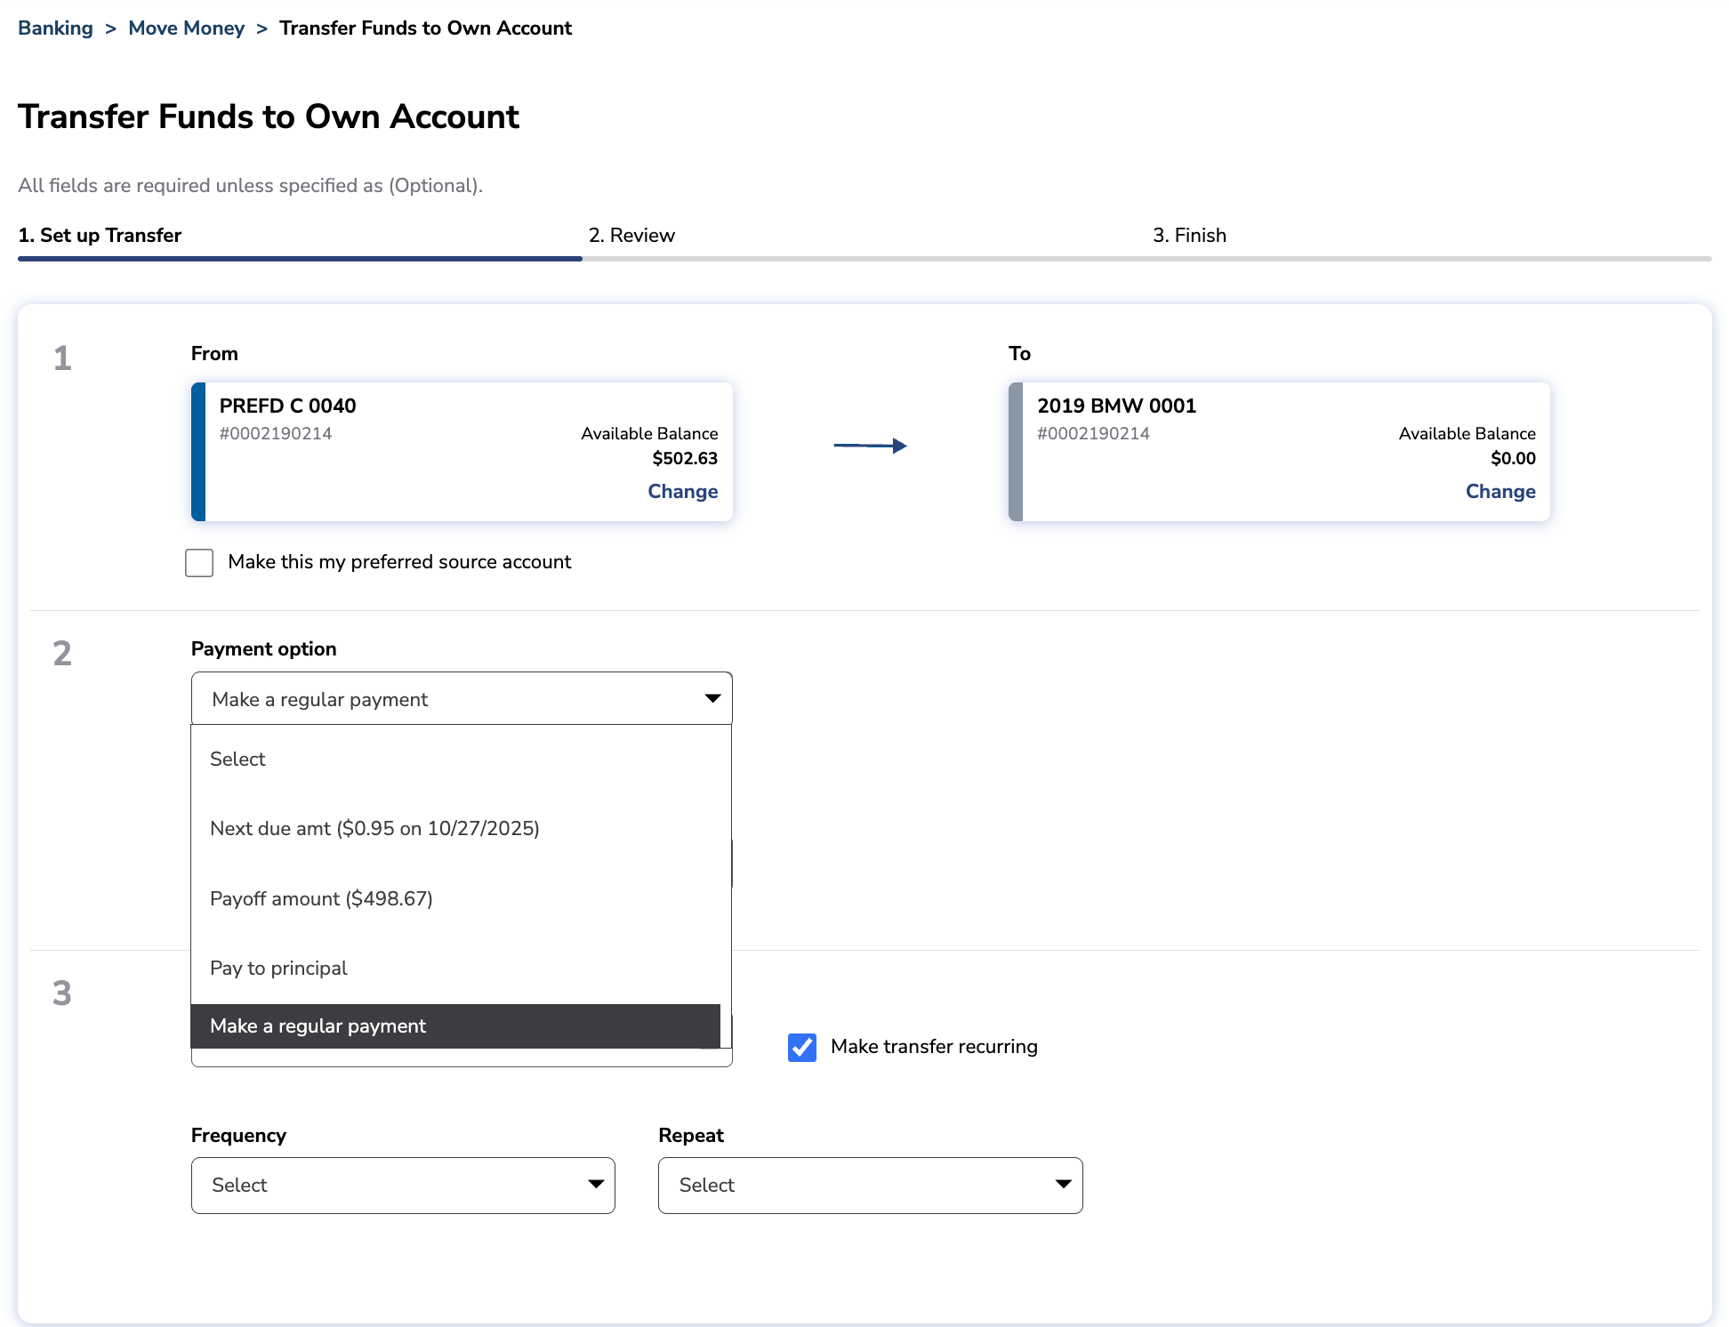
The Transfer Funds to Own Account screen opens with the three-step progress indicator (Set up Transfer → Review → Finish). Step 1 displays the From account (source checking/savings) and To account (the loan). The Payment Option dropdown provides four choices: Select (default), Next due amt, Payoff amount, Pay to principal, and Make a regular payment. The member also has the option to check “Make transfer recurring” to set up automated payments. The “Make this my preferred source account” checkbox allows saving the source account for future payments.
Step 4: Enter Payment Amount and Date
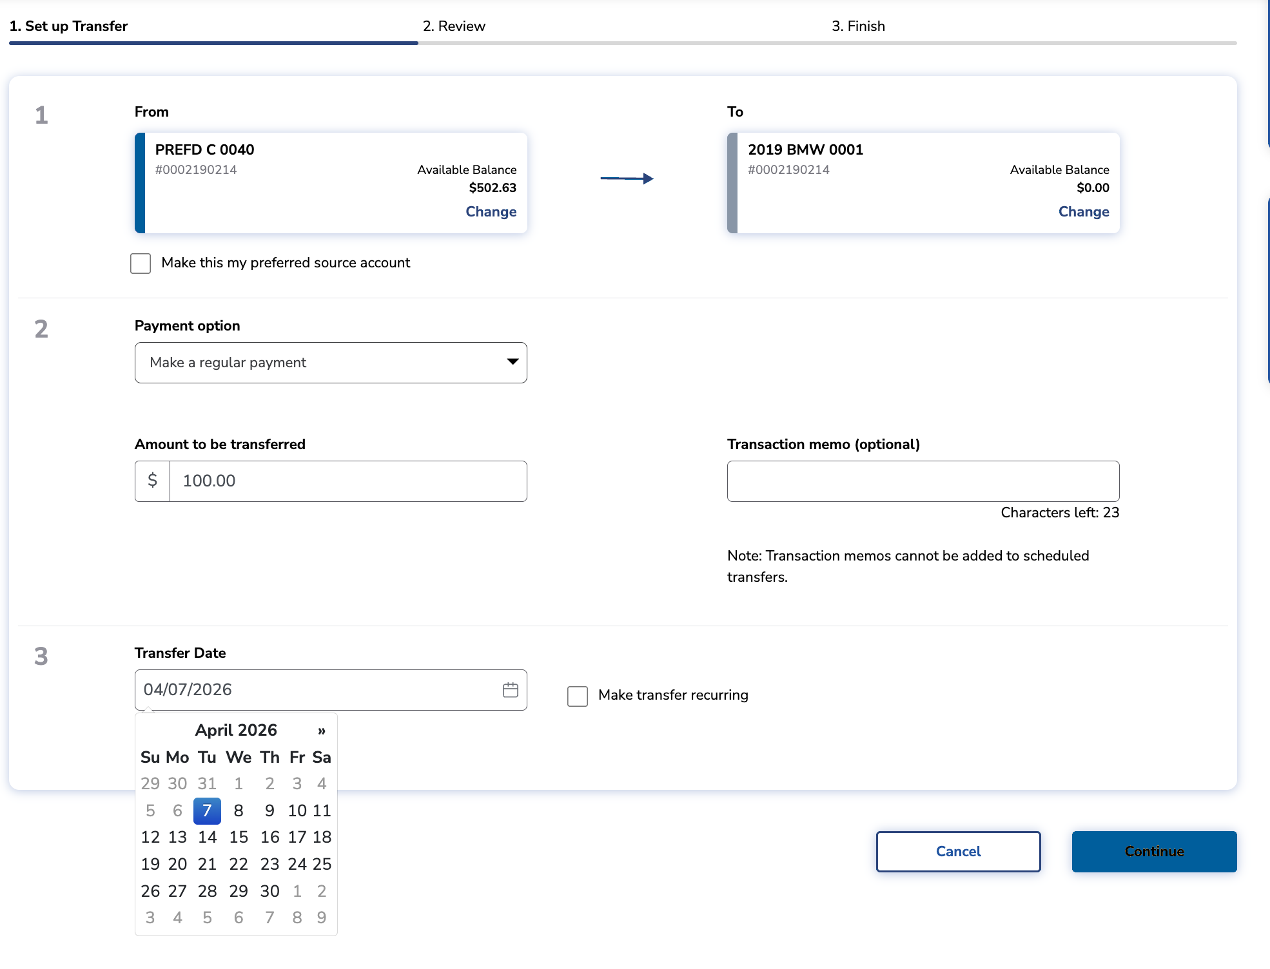
After selecting a payment option (e.g., “Make a regular payment”), the member enters the Amount to be transferred and an optional Transaction memo (limited to 23 characters). The Transfer Date field defaults to today’s date with a calendar picker for scheduling future payments. A “Make transfer recurring” checkbox is available for setting up automated payment schedules. The member clicks “Continue” to proceed to the review step.

Step 5: Configure Recurring Payment (Optional)
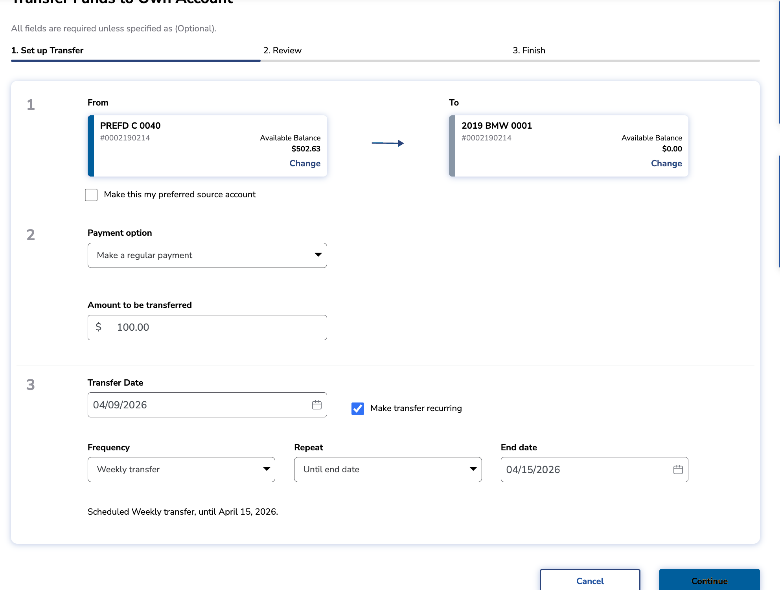
When “Make transfer recurring” is checked, additional scheduling fields appear: Frequency (Weekly transfer, Bi-Weekly, Monthly, etc.), Repeat (Until end date, Number of times, Until cancelled), and End Date. The system displays a confirmation summary such as “Scheduled Weekly transfer, until April 15, 2026.” This enables members to automate their loan payments on a consistent schedule, reducing the risk of missed payments.
Step 6: Review Transfer
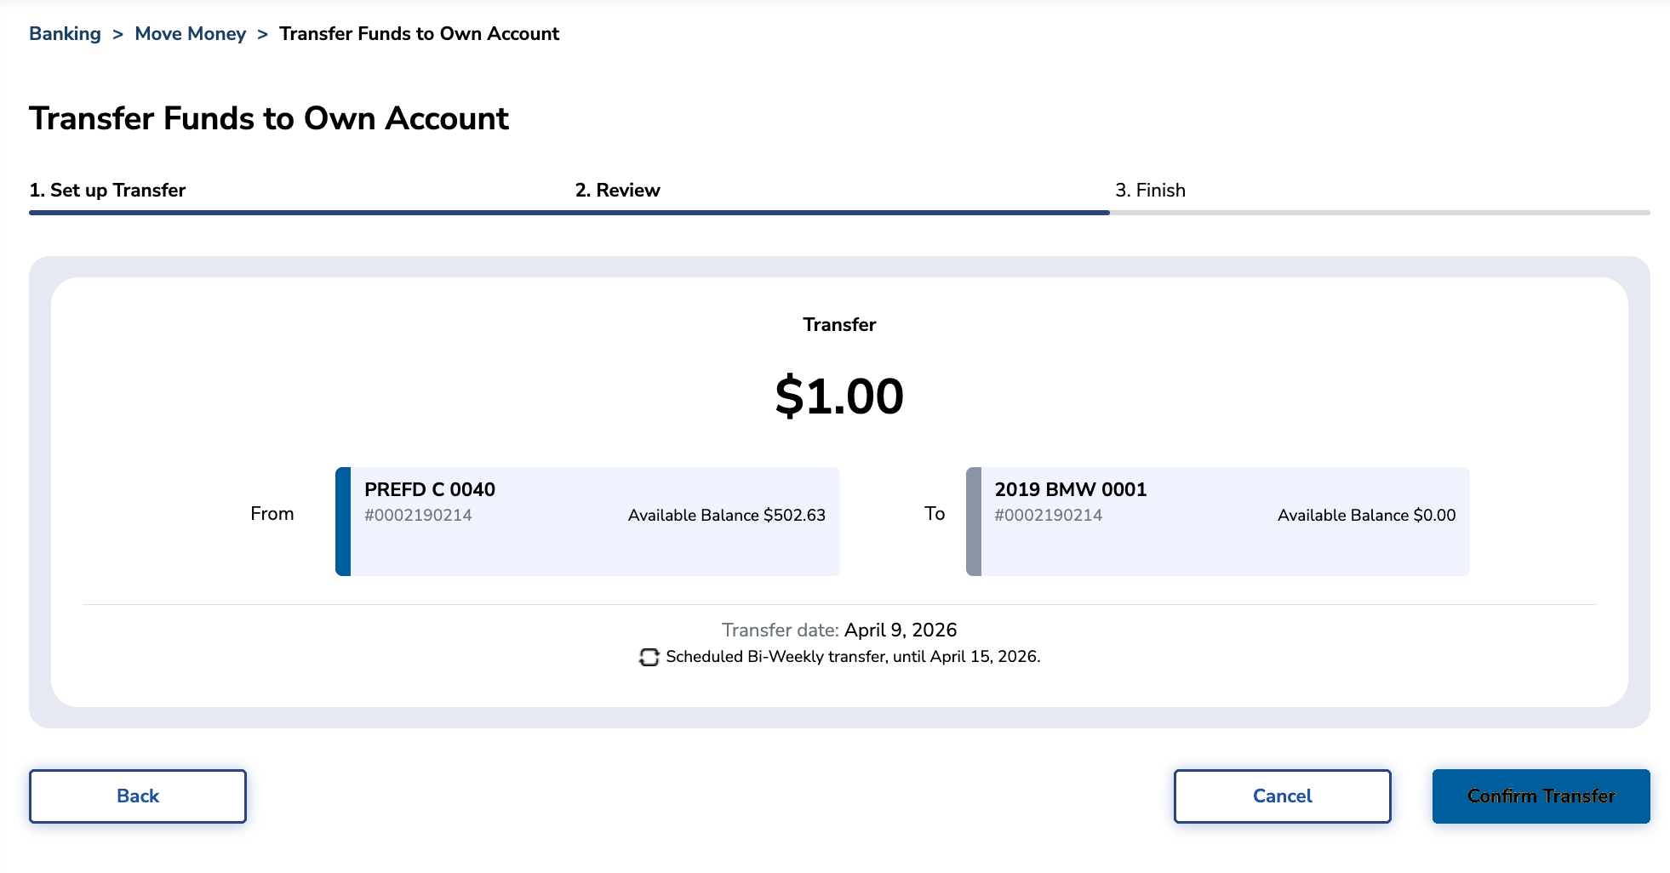
The Review screen (Step 2 of 3) presents a complete summary of the payment: the transfer amount ($1.00), From account (PREFD C 0040 with available balance), To account (2019 BMW 0001), Transfer date, and recurring schedule details if applicable. The member can click “Back” to modify any details, “Cancel” to abort, or “Confirm Transfer” to submit the payment. This review step ensures the member has full visibility before committing.

Step 7: Transfer Success
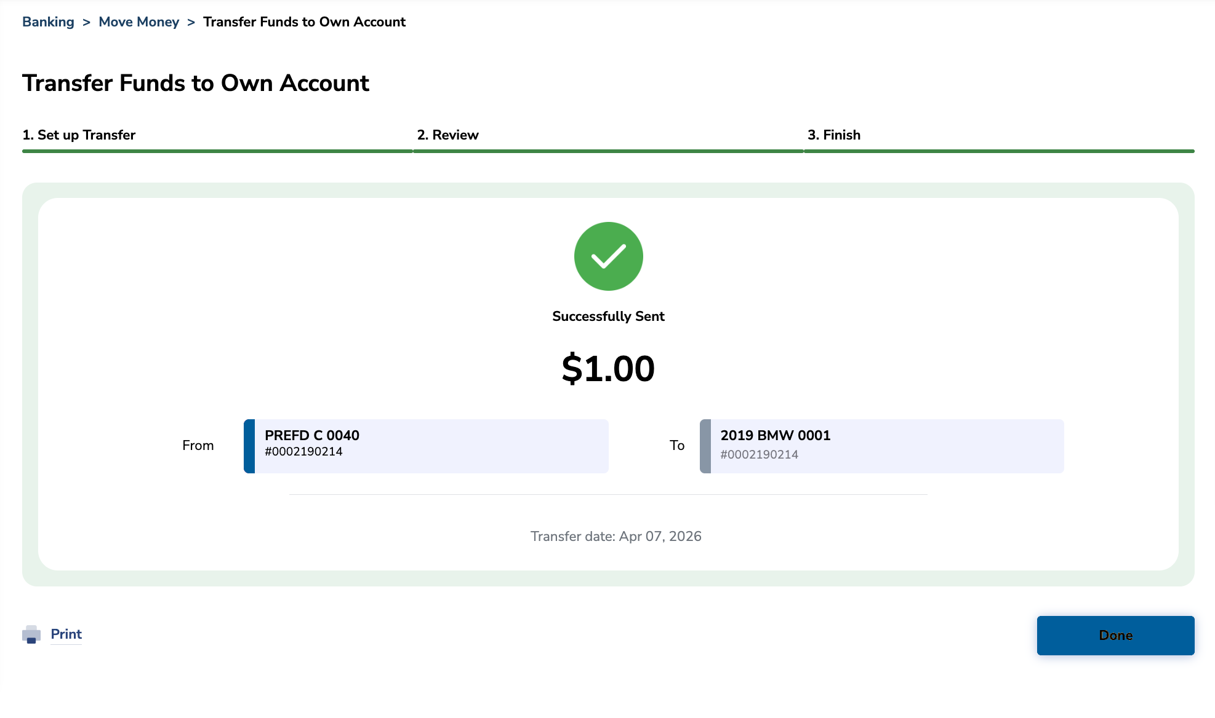
Upon successful submission, the Finish screen (Step 3 of 3) displays a green checkmark with “Successfully Sent” confirmation showing the transfer amount, source and destination accounts, and transfer date. A “Print” link allows the member to generate a receipt, and the “Done” button returns to the main banking view. The transaction is immediately recorded in the account’s transaction history.
3.3 Decision Points & Branching
The Loan Repayment workflow includes several decision points:
• Payment Option Selection: Choosing “Next due amt” or “Payoff amount” auto-populates the amount field from the loan’s API data. “Pay to principal” directs the entire payment to principal reduction. “Make a regular payment” allows free-form amount entry.
• Recurring vs. One-Time: Checking “Make transfer recurring” expands the form to show Frequency, Repeat, and End Date fields. Unchecked, the payment processes as a single one-time transfer.
• Transfer Date: Members can schedule payments for today (immediate) or a future date using the calendar picker. Future-dated payments appear as scheduled transfers in the member’s queue.
• Source Account Selection: Members can choose from any eligible funded account. The “Make this my preferred source account” checkbox stores the selection for future loan payments.
3.4 Completion & Confirmation
All loan payments conclude with a confirmation screen showing the transfer amount, source/destination accounts, and transfer date. For one-time payments, funds are debited immediately (or on the scheduled date). For recurring payments, the schedule is created and the first payment processes on the specified start date. Each transaction generates an audit log entry and appears in the loan account’s transaction history. Members can print a receipt from the success screen.
3.5 Error Handling
Common failure scenarios include: insufficient funds in the source account (displays balance error and prevents submission), amount exceeds payoff balance (validation error), invalid transfer date (past dates rejected), and system timeout during submission (retry option displayed). For scheduled recurring transfers, if a future payment fails due to insufficient funds, the system generates a failed transfer notification while subsequent scheduled payments continue.

4. Feature Overview (UI Walkthrough)

4.1 Loan Accounts Overview
Displays all loan accounts with key metrics and quick action links.
Field / Element | Type | Description | Notes
Account Name | Label | Loan account name (e.g., “2019 BMW 0001”) | Click to open Account Details
Membership Info | Label | Loan Account in Membership with account number | Read-only
Amount Due | Label | Current amount due on the loan | Displays “ℹ” info icon for details
Payment Due / Next Due Date | Label | Next payment amount and due date | Red text and “Overdue” badge if past due
Payoff Amount | Label | Total payoff balance for the loan | Includes “Transfer Funds” action link
History | Action Link | Opens transaction history for the loan | Blue text link
Transfer Funds | Action Link | Initiates the loan payment workflow | Navigates to Transfer Funds screen
Group by / Filter by | Dropdowns | Filter accounts by account group, membership, and type | Defaults to “Loan Accounts” when filtered
4.2 Loan Account Details
Detailed view of a single loan account with payment actions and transaction history.
Field / Element | Type | Description | Notes
Viewing account details for | Dropdown | Account selector to switch between loan accounts | Pre-populated with current loan
Edit account name | Action Link | Allows renaming the loan account | Blue text link
Amount Due | Label | Current payment amount due
Payment Due / Next Due Date | Label | Due date with overdue indicator if applicable | Red “Overdue” text for past-due amounts
Make Payment | Action Link | Initiates the Transfer Funds to Own Account flow | Primary entry point for loan repayment
Skip-a-Pay | Action Link | Opens skip-a-payment workflow if eligible | Subject to FI configuration
See more | Expandable Link | Reveals additional loan details (rate, term, etc.) | Toggles expanded view
Transactions | Table | Full transaction history with date, description, amount, balance | Searchable, exportable, printable

4.3 Transfer Funds — Set Up Transfer (Step 1)
The main payment setup form with account selection, payment options, and scheduling.
Field / Element | Type | Description | Notes
From Account | Account Card | Source account with name, number, and available balance | “Change” link to select different source
To Account | Account Card | Destination loan account with name, number, and balance | “Change” link to select different loan
Make this my preferred source account | Checkbox | Saves source account as default for future payments | Persists across sessions
Payment option | Dropdown | Select: Next due amt, Payoff amount, Pay to principal, Make a regular payment | Auto-populates amount for first three options
Amount to be transferred | Currency Input | Dollar amount for the payment | Pre-filled or manual entry based on option
Transaction memo (optional) | Text Input | Optional memo attached to the transfer | Max 23 characters; cannot be used with scheduled transfers
Transfer Date | Date Picker | Date for the payment to process | Calendar picker; defaults to today
Make transfer recurring | Checkbox | Enables recurring payment scheduling | Reveals Frequency, Repeat, and End Date fields
Frequency | Dropdown | Weekly, Bi-Weekly, Monthly, Quarterly, etc. | Visible only when recurring is checked
Repeat | Dropdown | Until end date, Number of times, Until cancelled | Controls recurrence termination
End date | Date Picker | Final date for recurring payments | Visible when “Until end date” is selected
Cancel | Button | Aborts the transfer and returns to previous screen | Secondary outlined button
Continue | Button | Validates inputs and proceeds to Review step | Primary blue button
4.4 Transfer Review (Step 2)
Confirmation screen displaying all payment details before submission.
Field / Element | Type | Description | Notes
Transfer Amount | Label | The payment amount displayed prominently | Large centered text
From Account | Account Card | Source account with available balance | Read-only summary
To Account | Account Card | Destination loan account | Read-only summary
Transfer date | Label | Scheduled payment date
Scheduled transfer details | Label | Recurring schedule summary if applicable | e.g., “Scheduled Bi-Weekly transfer, until April 15, 2026”
Back | Button | Returns to Step 1 with data retained | Left-aligned
Cancel | Button | Aborts the transfer | Secondary outlined button
Confirm Transfer | Button | Submits the payment for processing | Primary blue button

4.5 Transfer Success (Step 3)
Confirmation screen displayed after successful payment submission.
Field / Element | Type | Description | Notes
Success Icon | Graphic | Green checkmark indicating successful transfer
“Successfully Sent” | Label | Confirmation message with transfer amount | Large centered text
From / To Accounts | Account Cards | Source and destination accounts with balances | Read-only
Transfer date | Label | Date the payment was processed
Print | Action Link | Generates a printable receipt of the transaction | Opens print dialog
Done | Button | Returns to the main banking view | Primary blue button

5. Quick Reference

Task | Navigation Path | Who Can Do It | Notes
View loan accounts | Accounts > Accounts Overview > Filter: Loan Accounts | Account Holder | Shows all loans with payment status
Make a loan payment | Account Details > Make Payment > Set up Transfer > Review > Confirm | Account Holder | 3-step guided workflow
Pay next due amount | Make Payment > Payment option: Next due amt | Account Holder | Auto-populates minimum payment due
Pay off loan | Make Payment > Payment option: Payoff amount | Account Holder | Auto-populates full remaining balance
Pay to principal | Make Payment > Payment option: Pay to principal | Account Holder | Entire payment applied to principal
Set up recurring payment | Make Payment > Check “Make transfer recurring” > Set frequency/end date | Account Holder | Automates future payments on schedule
View payment history | Account Details > Transactions | Account Holder | Searchable, exportable, printable
Print payment receipt | Transfer Success > Print | Account Holder | Available after successful payment

6. Conclusion

Loan Repayment is a foundational self-service capability for Summerville Federal Credit Union’s digital banking offering on the nFinia platform. The feature addresses a critical member need by enabling convenient, flexible loan payments through the same Transfer Funds infrastructure used across the platform, ensuring a consistent and familiar user experience.

The guided three-step workflow (Set up Transfer → Review → Finish) with clear confirmation screens ensures members make informed payment decisions. The multiple payment options — next due amount, payoff, pay-to-principal, and regular payments — cater to diverse member needs, from minimum obligation fulfillment to accelerated debt reduction. The recurring payment capability is particularly valuable for reducing delinquency by automating consistent repayment schedules.

For Summerville FCU, Loan Repayment strengthens member retention by removing friction from the repayment process. Members who can easily manage their loan payments digitally are less likely to fall behind and more likely to remain engaged with the credit union for future lending needs. The feature reduces contact center volume for routine payment inquiries and provides full transaction audit trails that support the credit union’s operational and compliance requirements.

